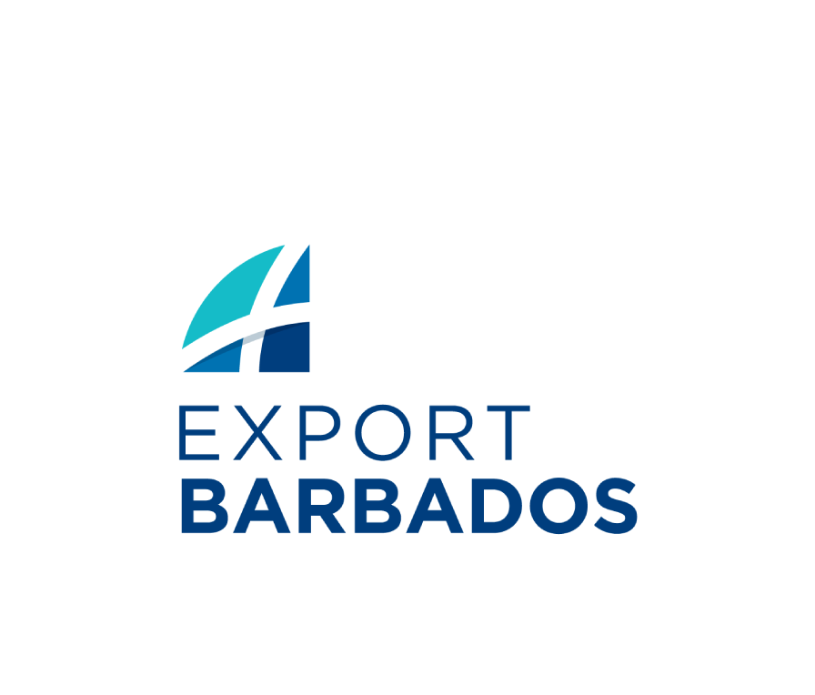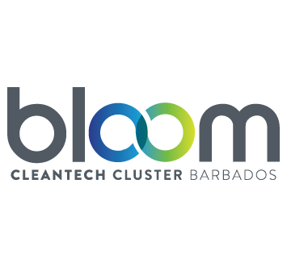
THE BARBADOS BLOOM CLEANTECH CLUSTER
Application Form
To be completed and submitted ELECTRONICALLY
Please submit to jsargeant@bidc.org

Name of Organization (If Applicable):  ………………………………………………………………………………..  ………………………………………………………………………………..  ……………………………………………………………………………….. | Main Contact Person (name, surname):  …………………………………………………………………………………  ………………………………………………………………………………..  Job Title: ………………………………………………………………….
Business Address: ……………………………………………………………………………….  ……………………………………………………………………………….. | Sex * Male Female  Age Group*  18-24 years  25-29 years  30-34 years  35-39 years  40-19 years  >50 years
Telephone No.:
……………………………………………………............................
……………………………………………………...........................
Email: …………………………………………............................  Social Media:  ……………………………………………………........................... | Fax No.: ……………………………………………………………………  Website: ………………………………………………………………….  ………………………………………………………………………………..
- Briefly describe the proposed product or service activity in which your business is or will be engaged? What is the current stage of development of product or service (e.g., Business idea, feasibility study, working prototype, product in development, marketable product, production started):

How much money has been invested for the development of your business idea and product so far?
In-kind
Less than 100,000 BBD
100,000-500,000 BBD
0.5 - 1 million BBD
More
Type of financing used to operate business to-date:
Personal
Grant
Loan financing
Private investors
Venture capital firms
Not Applicable
Have you already obtained the required permits or licenses for operation?
Yes
No
If YES please attach a copy of each permit or license
Current sales revenue (BBD per annum):
No sales yet
< 50,000 BBD
50,000 - 100,000 BB
100,000 - 500,000 BBD
0.5 - 1 million BBD
1-5 million BBD

- Description of the team (Key members, work experience in years, areas of expertise, description of the duties in product development, marketing & sales) please attach CVs of team members:

- How many people will your business employ in its first year of being in the Cleantech Incubator Programme?
Full-time *
Part-time *
- Who do you perceive will be your main competitors?

- State any advantage(s) your product/service has or will have over your competitors

- Identify the main risks that could threaten the growth of your business:

- What factors could increase demand for your product/service or lead to the expansion of your business?

- Describe your target market and your plans to engage customers (total market size, total size of the addressable market, potential first customers, client commitments):

- What is the status of your Business Plan?
Completed (please attach a copy)
In preparation and available by _________
Not yet started

- Do you require help in writing a business plan?
Yes
No

- What are your space needs?
Open office space
Makers space for prototyping and testing

- How did you hear about this Program?
Email Website Social Media

Other (please specify) ---------------------------------------------------

